STOCK MANAGEMENT

USE CASE DIAGRAM

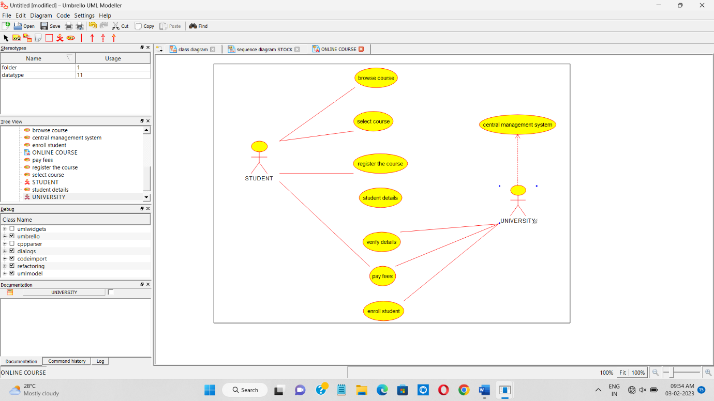

CLASS DIAGRAM

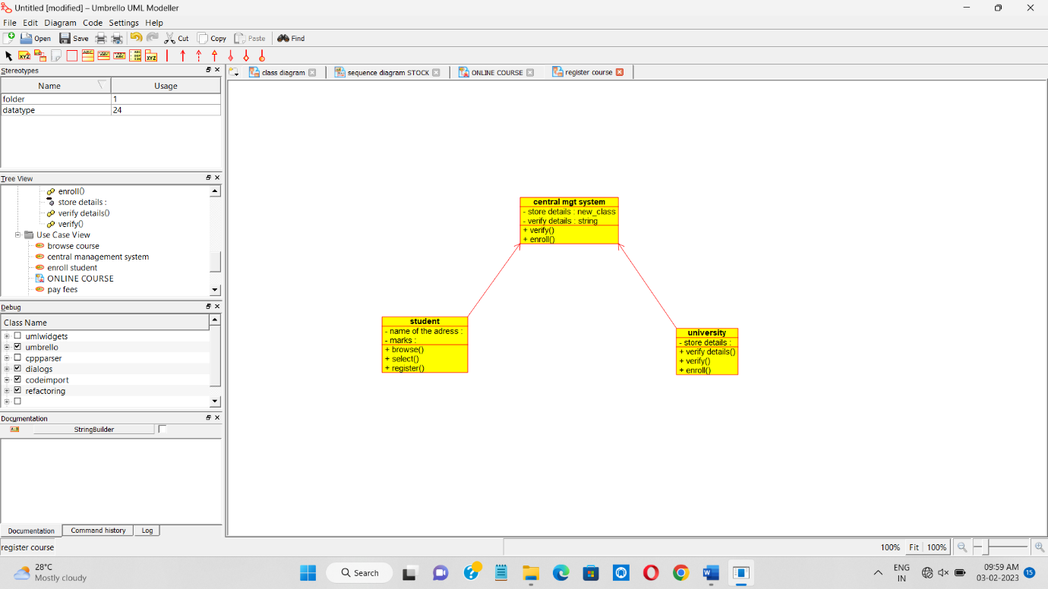

ACTIVITY DIAGRAM

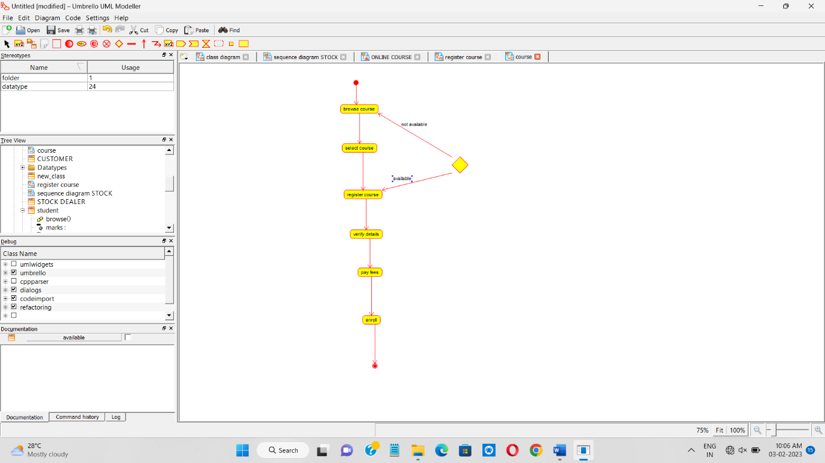

SEQUENCE DIAGRAM

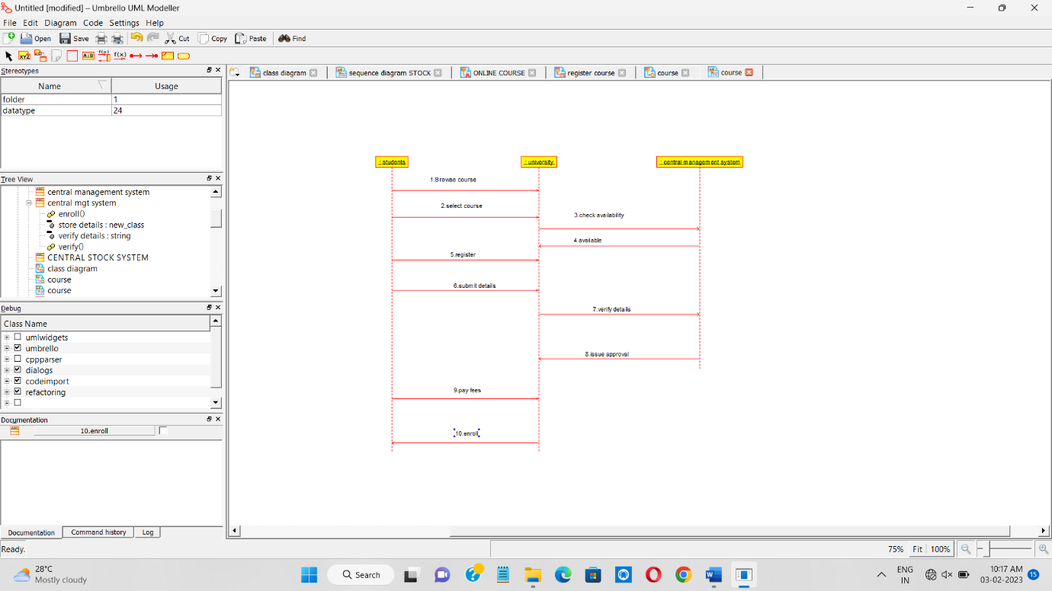

COLLABORATION DIAGRAM

